Individual Bios
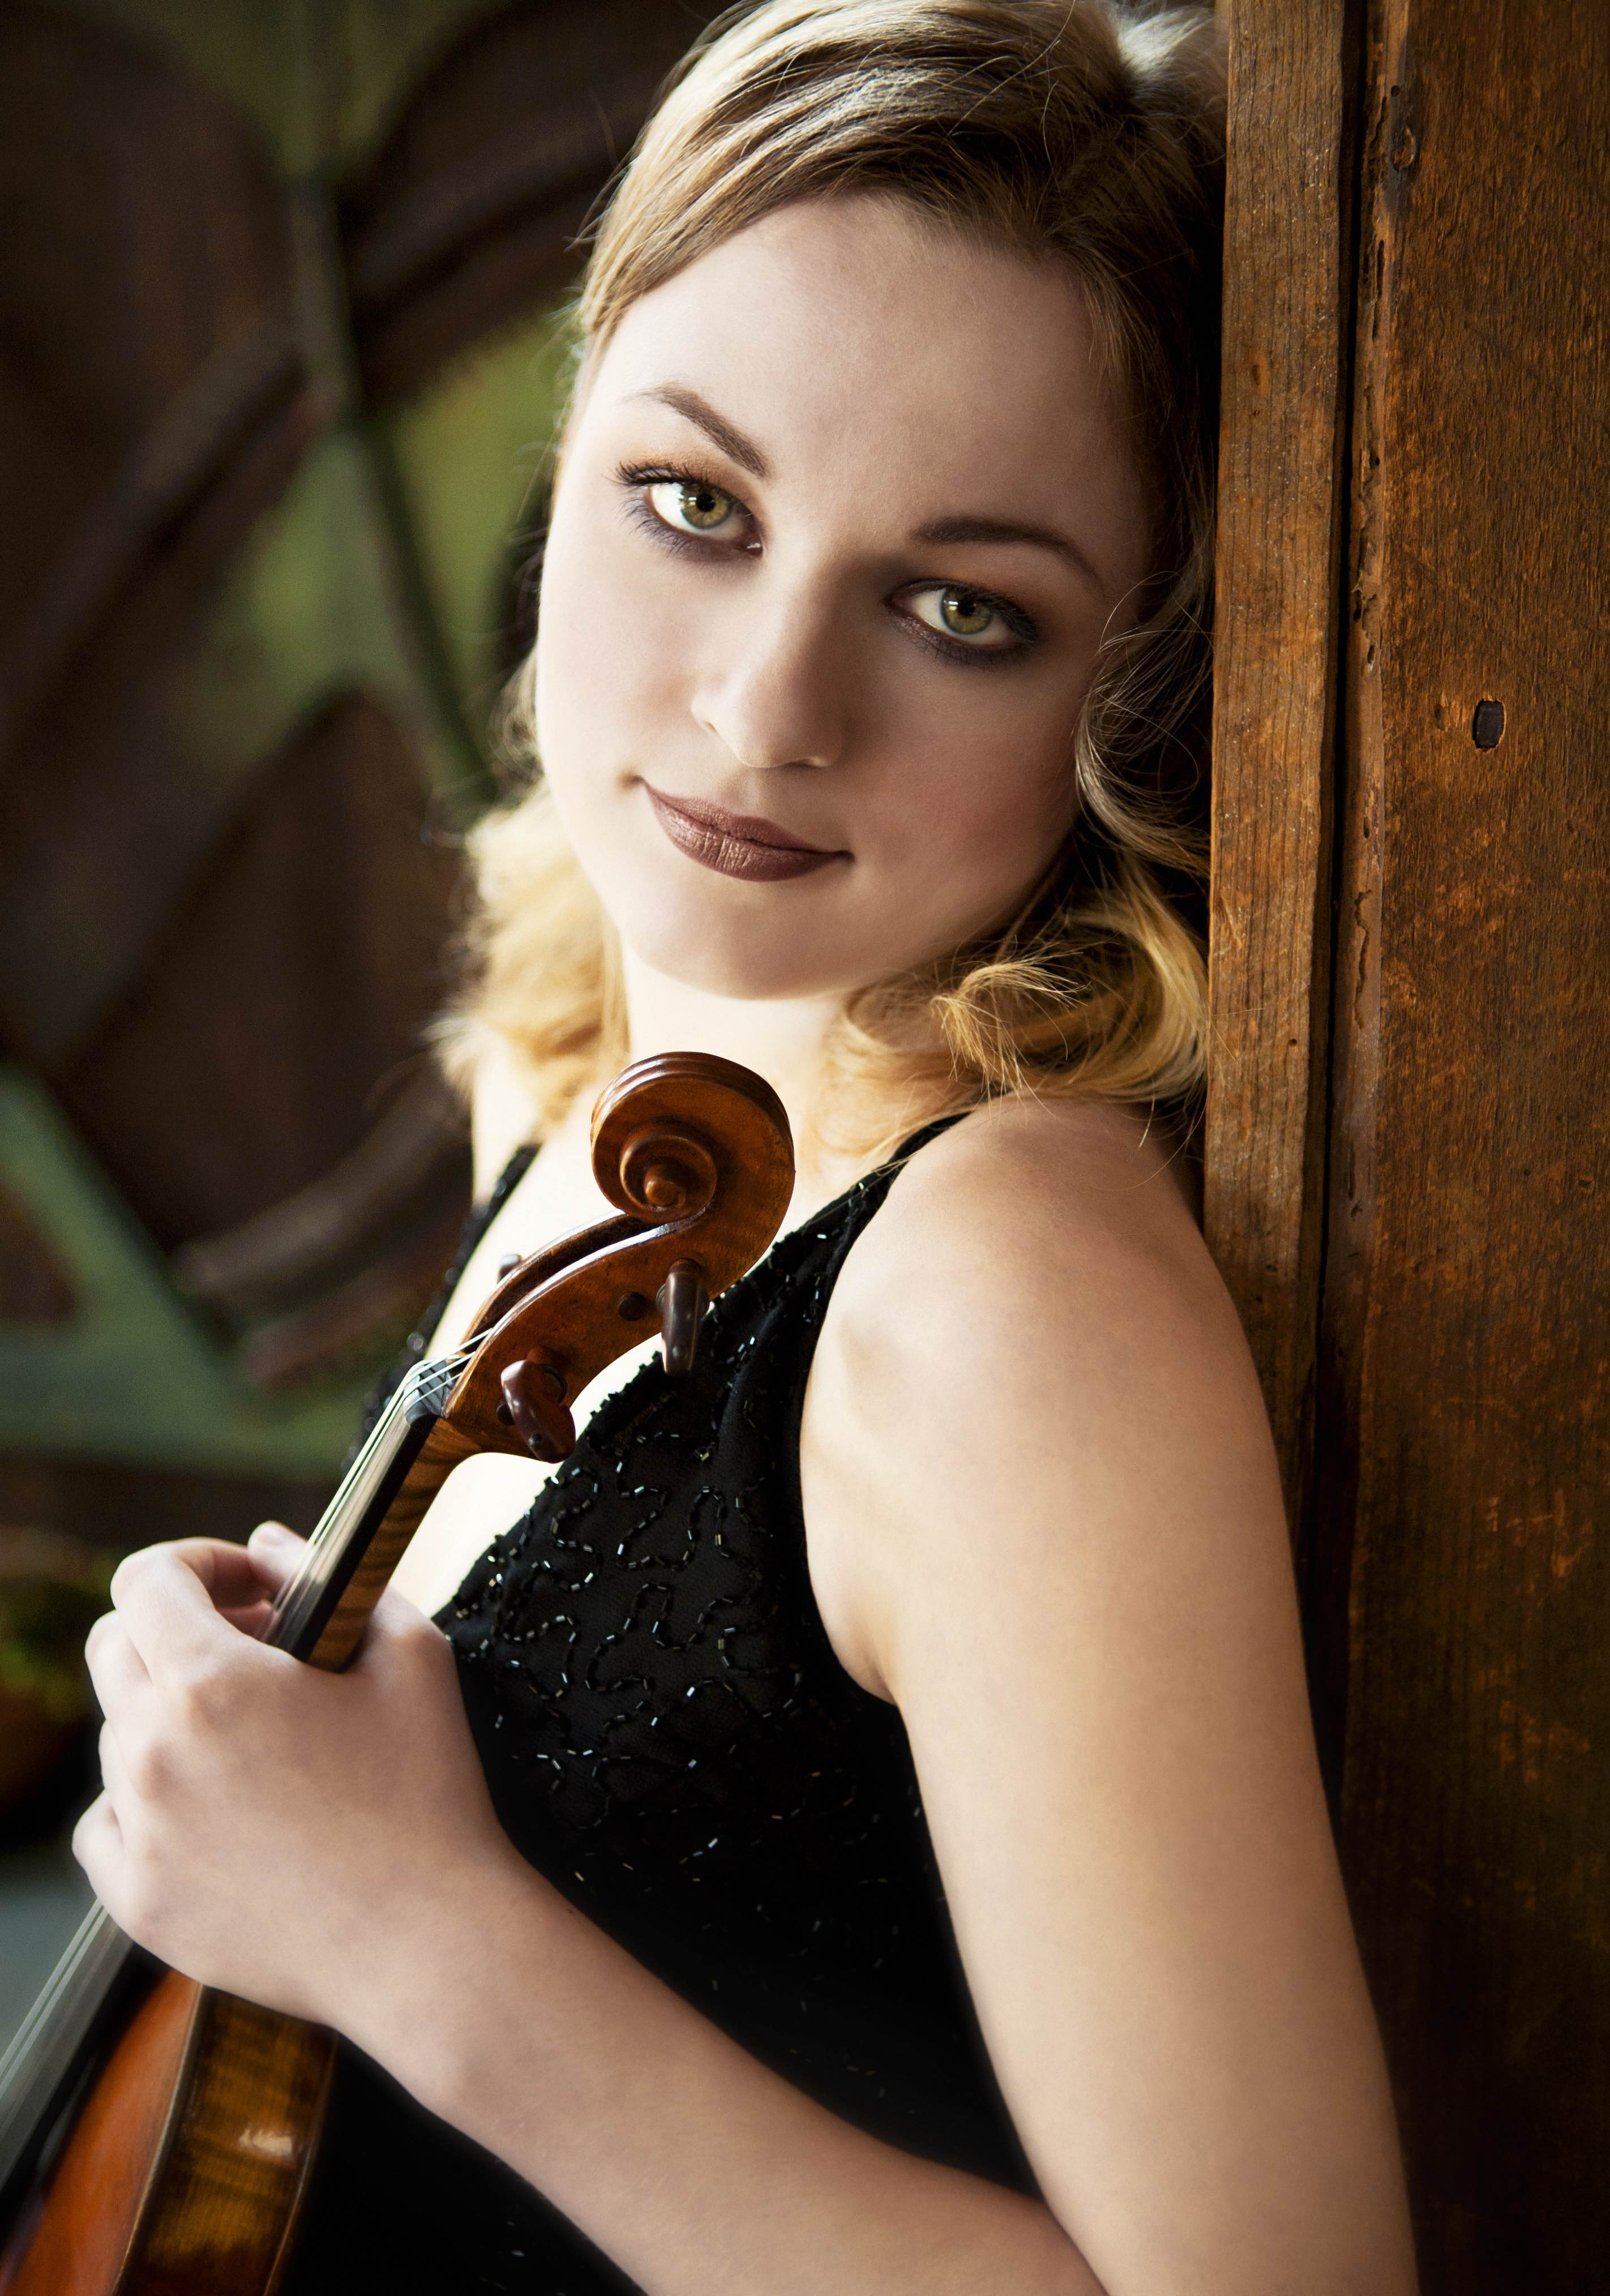
Ukrainian violinist Marta Krechkovsky joined the Pittsburgh Symphony Orchestra at the beginning of the 2014-2015 season. An experienced performer of orchestral and chamber music, she has participated in numerous music festivals such as Pacific Music Festival and Verbier Festival, where she has served as a concertmaster. She also took part in Miyazaki International Music Festival and was invited to perform with World Orchestra for Peace as a tribute to Sir Georg Solti on the occasion of the 100th anniversary of his birth. She is currently a violinist with the Grand Teton Music Festival in Jackson Hole, Wyoming.
An active chamber musician, Ms. Krechkovsky has appeared in New York’s concert halls such as Carnegie's Weill Recital Hall, Lincoln Center's Alice Tully Hall and Bargemusic in Brooklyn, as well as Kitara Chamber Music Hall in Sapporo, Japan. A few chamber music highlights include performances with Yo-Yo Ma, Julian Rachlin, and the St. Lawrence String Quartet at the Grand Teton Music Festival, as well as Augustin Hadelich, Narek Hakhnazaryan, Benjamin Grosvenor and Pablo Sáinz-Villegas.
Marta Krechkovsky is a member of the Clarion Quartet, a quartet formed by members of the Pittsburgh Symphony Orchestra that specializes in “Entartete Musik.” Clarion Quartet’s debut album, Breaking the Silence, was released in February of 2018 on the TYE/Naxos label.
Ms. Krechkovsky became a prizewinner at Kocian International Violin Competition in Czech Republic at the age of 10 and was a top-prize winner at Canadian Music Competition in Montreal. As a soloist, Ms. Krechkovsky has appeared with numerous orchestras in her native Ukraine, including the Lviv State Symphony Orchestra. She performed Bach's Double concerto with Joshua Bell and the Verbier Festival Chamber Orchestra during their Asia tour, and in 2021 she performed Tchaikovsky’s Violin Concerto with the Pittsburgh Symphony Orchestra.
Ms. Krechkovsky began studying violin at the age of six with her father, Orest Krechkovsky. She received her earlier training at Young Artists Performance Academy at the Royal Conservatory of Music in Toronto, where she studied with Atis Bankas. She holds Bachelor of Music and Master of Music degrees from The Juilliard School where she studied with Glenn Dicterow, and a professional studies degree in orchestral performance from the Manhattan School of Music where she studied with Glenn Dicterow and Lisa Kim.
Violinist Jennifer Orchard has called Pittsburgh her home since 2001. She is a member of the first violin section of the illustrious Pittsburgh Symphony and also the Clarion Quartet, which focuses on the music of suppressed composers. Performing mostly music by Jewish composers who suffered exile and execution at the hand of the Nazis, the quartet recorded three such works for Naxos called “Breaking the Silence”. They have embarked on a mission to include any composer who has not received the critical acclaim they deserve, including women and composers of African descent, and will continue to explore this great unknown world of classical music.
Orchard’s diverse musical interests also include the music of Russian Romantic period composer, Paul Juon. Teaming up with pianist Igor Kraevsky, the duo recorded two world premier CDs of all of Juon’s works for violin and piano.
In her first career, Jennifer was a member of the world renowned Lark Quartet and recorded extensively under the Arabesque label during her eight-year tenure with this group.
Orchard received her bachelors degree from the Curtis Institute and her masters from The Juilliard School. She won a coveted position at the Marlboro Festival and was also invited to perform chamber music in Mumbai, India. At the invitation of famed composer/conductor, Marvin Hamlisch, she was a guest of honor performing with Marvin at the piano at the Kuwaiti embassy. Recently, Orchard has branched out to include some fiddle playing and has recorded and performed with singer songwriter, Andrew Lipke.
Orchard plays an Andreas Guarnerius violin.

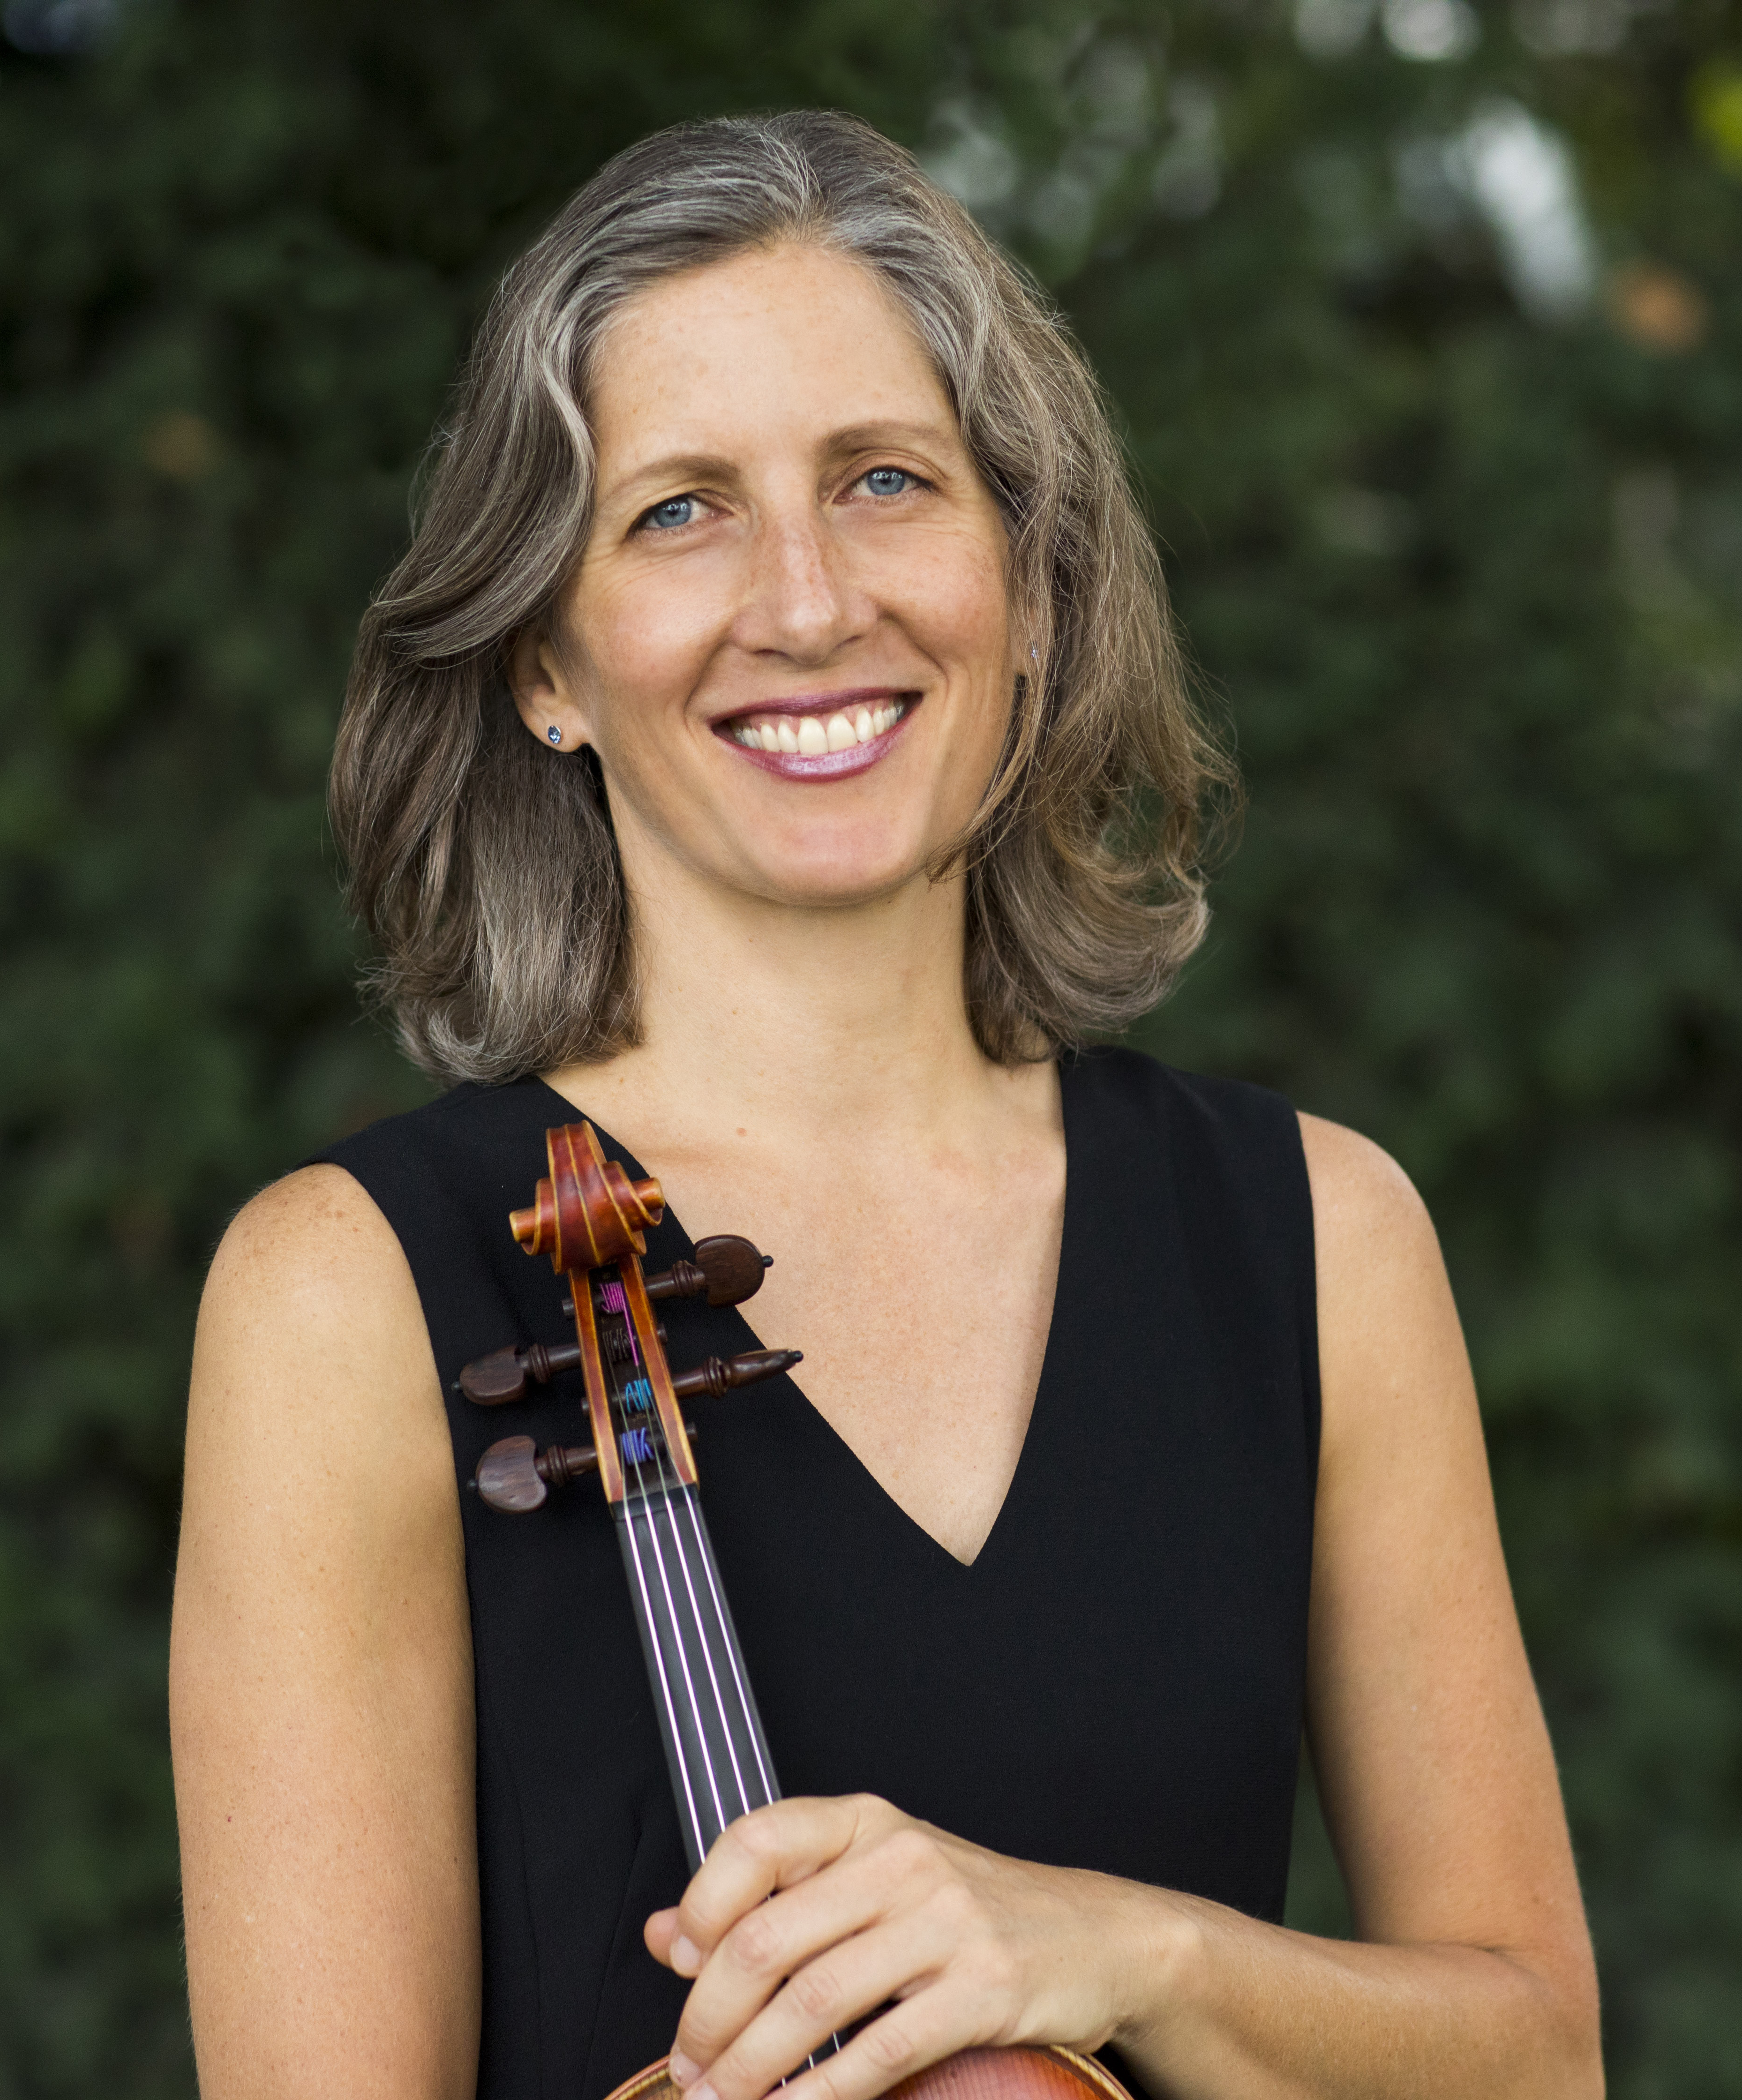
Tatjana Mead Chamis, Associate Principal Viola of the Pittsburgh Symphony Orchestra, joined the orchestra in 1993 under the direction of Lorin Maazel. She has appeared as soloist with the Porto Alegre and Sao Paulo Symphony Orchestras of Brazil, the Utah Symphony, the Curtis Institute Symphony Orchestra, and numerous times with the Pittsburgh Symphony and the Pittsburgh Symphony Chamber Orchestra. Nominated in 2017 for a Latin Grammy for her performance of the Sonata for Viola and Piano, dedicated to her by the Brazilian composer/pianist, André Mehmari, Ms. Chamis is finishing a project of recording music for Viola by Brazilian composers. Her performances as a recitalist and chamber musician have been broadcast on NPR and WQED in Pittsburgh.
Ms. Chamis began her studies in Frankfurt, Germany, on the violin, at the age of seven. At 15, she switched to the viola while studying with violist Mikhail Boguslavsky, in Salt Lake City, Utah. A 1994 graduate of the Curtis Institute of Music, she studied with Philadelphia Orchestra Principal Violist, Joseph dePasquale.
In 2016, Ms. Chamis founded the Clarion Quartet with three other members of the Pittsburgh Symphony. The virtuoso ensemble is dedicated to bringing to light the works of composers silenced by oppression. She is a former member of the Caramoor Virtuosi and Rising Stars at the Caramoor International Music Festival in New York, and has performed at the Bravo Festival in Vail, Colorado, the Halcyon Festival, the Green Bay Music Festival with members of the Amelia Piano Trio, and the Tanglewood Music Festival.
A frequent guest lecturer, Ms. Chamis joined the Carnegie Mellon School of Music faculty in 2016.

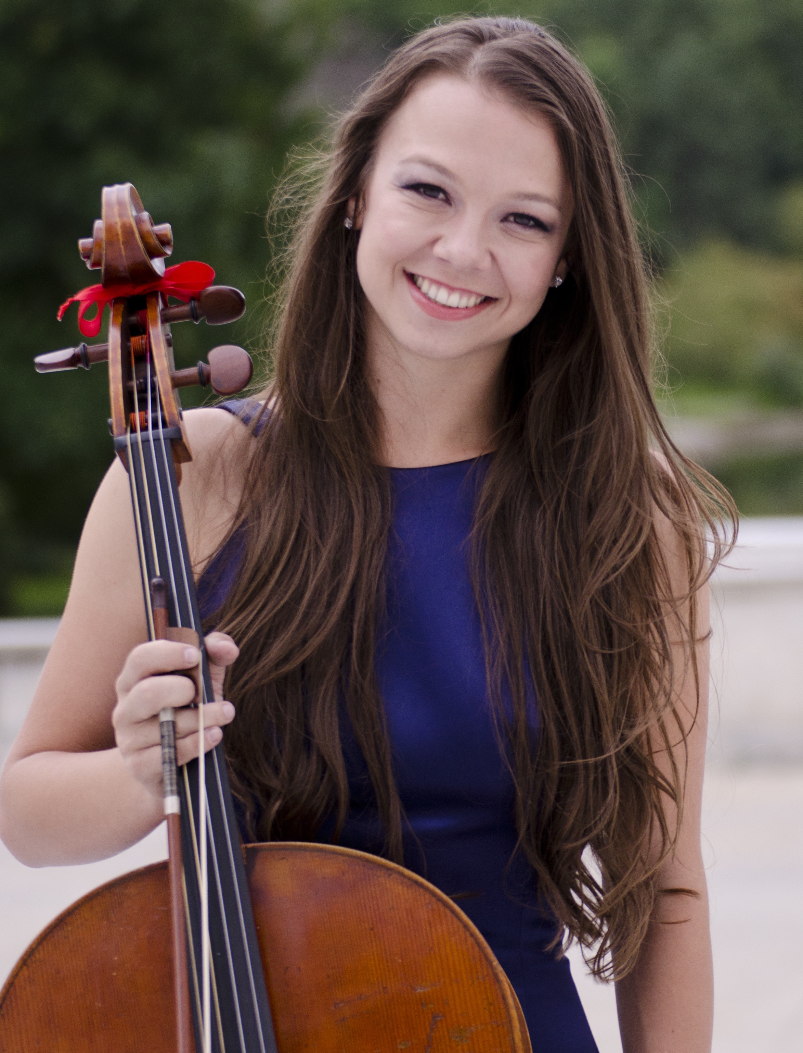
Bronwyn Banerdt joined the cello section of the Pittsburgh Symphony Orchestra in 2014. She made her solo debut with Los Angeles Philharmonic in 2002 and has since appeared in concert throughout the United States, Europe, Russia, and southern Africa. Notable solo appearances include performances with the Pittsburgh Symphony, Houston Symphony, Albany Symphony, and the world premiere of Poem for Cello & Orchestra by Michael Kamen. At age 15 Ms. Banerdt was personally invited by the world-renowned composer John Rutter to perform the solo from his Requiem in Carnegie Hall. Ms. Banerdt was awarded Grand Prize at the Los Angeles Philharmonic’s Bronislaw Kaper Awards, and she has also captured top prizes at the Houston Symphony Ima Hogg Competition and Kingsville Music Competition.
Equally passionate about chamber music and orchestral performance, Ms. Banerdt has co-founded two uniquely focused chamber music ensembles with other members of the Pittsburgh Symphony. The Clarion Quartet specializes in Entartete Musik — music written by oppressed composers — and seeks to bring light to artists whose legacies would be silenced. The Pittsburgh Cello Quartet offers an eclectic mix from classical to pop and rock in unique arrangements for four cellos. Ms. Banerdt has collaborated with renowned artists such as Kim Kashkashian and Mitsuko Uchida, and members of the Emerson, Guarneri, Juilliard, Borodin, and Orion string quartets. She has performed at numerous chamber music festivals including Marlboro Music and Music from Angel Fire. Before joining the PSO, Ms. Banerdt was a member of the prize-winning Trio Terzetto and performed as a substitute with many of the great orchestras of the world, including the New York Philharmonic, Philadelphia Orchestra, Cleveland Orchestra, Detroit Symphony, and Lyric Opera of Chicago.
A native of Los Angeles, Ms. Banerdt earned her Bachelor’s Degree at age 19 from the USC Thornton School of Music, where she studied with Ronald Leonard. She subsequently studied at The Curtis Institute of Music with David Soyer and received her Master’s Degree from The Juilliard School with Richard Aaron.
Ms. Banerdt plays a Montagnana model cello made by Mario Miralles in 1998.

